**How to download the codes and training materials**

* Go to github in [https://github.com/kevinlee1004/PharmaSUG21_Python_Training_Basic](https://www.anaconda.com/products/individual)
* Click on “Code” and "Download zip" in <https://github.com/kevinlee1004/PharmaSUG21_Python_Training_Basic>

**How to install Anaconda (Jupyter Notebook)**

* Go to Anaconda website in <https://www.anaconda.com/products/individual>
* Click on "Download"

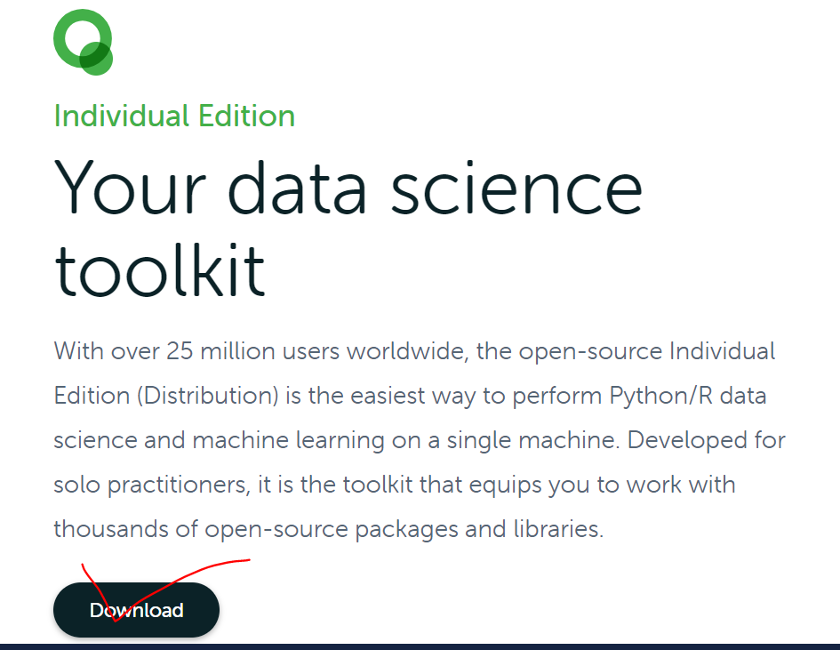

* There are three different OS system. You can choose the one appropriate for your system. On this example, we select “Windows”.

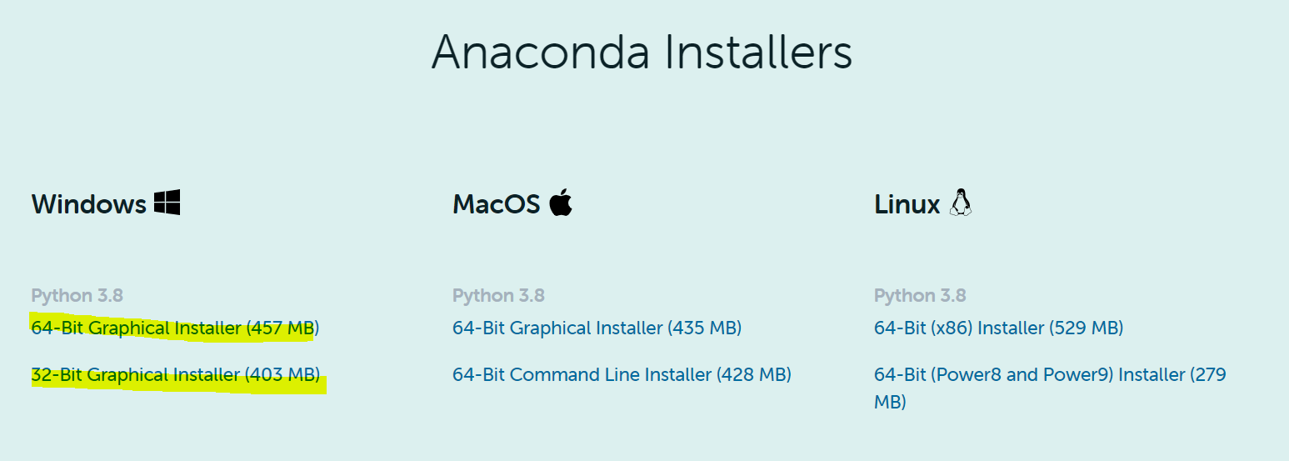

* It will download executable files Anaconda - Anaconda3-2020.11-Windows-x86_64.exe.
* Open Anaconda executable file and follow the instructions to install Anaconda (Jupyter notebook).

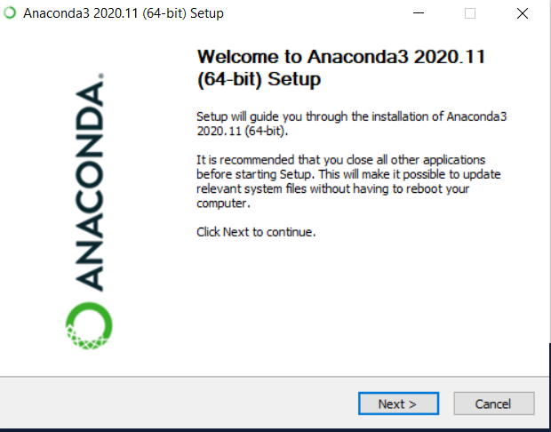

* Once Anaconda is installed, you will see "Anaconda Prompt" application in your computer.

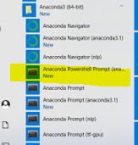

* Click on “Anaconda Prompt”. It will open “Anaconda Prompt” Command line as shown below.
* Change the directory to where your python codes are saved by typing “cd …” and enter it.

* Type “jupyter notebook” and enter
* It will open Jupyter notebook in your browser like below.

**How to download the necessary package.**

Once Anaconda Prompt is installed, you can download Python packages.

For example, type “conda install sas7bdat” on “Anaconda Prompt” command line as shown below.

Type “conda install sas7bdat”

Below are the python packages that you need to download.

* (base) C:\Users\kevin>pip install xport==2.0.2
* (base) C:\Users\kevin>conda install sas7bdat
* (base) C:\Users\kevin>pip install pyreadstat
* (base) C:\Users\kevin>conda install pyarrow
* (base) C:\Users\kevin>pip install python-snappy
* (base) C:\Users\kevin>conda install fastparquet